**Title: Unleashing Efficiency: Control SMX BT - Advancing Nutrunner Systems**

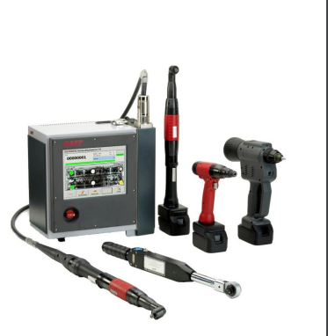  
In the dynamic landscape of assembly operations, efficiency is paramount. Enter the Control SMX BT, a state-of-the-art [nutrunner control system by AMT](https://absgroup.in/products-category/controller), designed to seamlessly integrate battery tools, cable-based tools, torque wrenches, and battery riveters. This article explores the possibilities, operation, display features, parameterization capabilities, and technical data that make the Control SMX BT a game-changer in nutrunning systems.

**Possibilities and Integration:**

- Battery tools can be connected to the [nutrunner control system](https://absgroup.in/products-category/controller) alongside cable-based tools, torque wrenches, and battery riveters.

- Seamless communication with customer controls, command management, and transmission of results to the customer database.

- Optimal design flexibility for [the nutrunning system](https://absgroup.in/products-category/controller), reducing room and hardware requirements.

- Shared hard- and software streamline commissioning and maintenance, saving time and costs.

- Enhanced productivity, reduced operating costs, and improved efficiency.

**Operation and Display:**

- Operation and administration directly at [the nutrunner control system.](https://absgroup.in/products-category/controller)

- 10.4“ touch screen for programming and parameterization.

- Hierarchic password management for secure settings.

- User-oriented, menu-guided "touch display user surface" eliminates the need for a keyboard or mouse.

- Low-depth enclosure (205 mm) for direct installation at the assembly line, providing quick and comfortable access.

**Parameterization:**

- Programming and parameterization via the 10.4“ touch display.

- Diagram-supported parameterization of individual tightening phases.

- Easy entry of switch-off and monitoring parameters through the ergonomic touch display.

- Comfortable menu navigation for compiling individual tightening tasks.

- Integrated sequence control for solving complex tasks.

**Analysis:**

- High-performance analysis tools for reliable reports, even with large datasets.

- User-friendly software interface for occasional users.

**Technical Data - Control SMX40 BT:**

- Work station control for up to 10 rechargeable tools.

- Interface for other OEM tools[, assembly control systems](https://absgroup.in/products-category/controller), and host computers.

- Nutrunner data transfer to quality safety systems, statistical analysis, and graphic display.

- Compact Flash Card, 2x Ethernet interface 10/100Mbit, 3x Serial interface, 4x USB interface.

- 10.4“ touch-screen display for integrated operator and parameter interface.

- Network-based programming and parameterization.

- Versatile periphery options including operator control, socket box, indicators, signal exchange with SPS, barcode reader, and data media compatibility (e.g., Moby E).

**Conclusion:**

[The Control SMX BT from AMT](https://absgroup.in/products-category/controller) is not just a control system; it's a catalyst for enhanced efficiency, reduced costs, and improved productivity in your assembly operations. Embrace the future of [nutrunner systems](https://absgroup.in/products-category/controller) with seamless integration and user-friendly interfaces, setting new standards in assembly line performance.